# Department of Computer Technology

### Vision of the Department

*To be a well-known centre for pursuing computer education through innovative pedagogy, value-based education and industry collaboration.*

### Mission of the Department

*To establish learning ambience for ushering in computer engineering professionals in core and multidisciplinary area by developing Problem- solving skills through emerging technologies****.***

## Session 2025-2026



**Program Educational Objectives of the program (PEO):** (broad statements that describe the professional and career accomplishments)

| PEO1 | **Preparation** | **P: Preparation** | **Pep-CL abbreviation**  **pronounce as Pep-si-lL easy to recall** |
| --- | --- | --- | --- |
| PEO2 | **Core Competence** | **E: Environment (Learning Environment)** |
| PEO3 | **Breadth** | **P: Professionalism** |
| PEO4 | **Professionalism** | **C: Core Competence** |
| PEO5 | **Learning**  **Environment** | **L: Breadth (Learning in diverse areas)** |

**Program Outcomes (PO):** (statements that describe what a student should be able to do and know by the end of a program)

## Keywords of POs:

Engineering knowledge, Problem analysis, Design/development of solutions, Conduct Investigations of Complex Problems, Engineering Tool Usage, The Engineer and The World, Ethics, Individual and Collaborative Team work, Communication, Project Management and Finance, Life-Long Learning

**PSO Keywords:** Cutting edge technologies, Research

“I am an engineer, and I know how to apply engineering knowledge to investigate, analyse and design solutions to complex problems using tools for entire world following all ethics in a collaborative way with proper management skills throughout my life.” *to contribute to the development of cutting-edge technologies and Research*.

**Integrity:** I will adhere to the Laboratory Code of Conduct and ethics in its entirety.

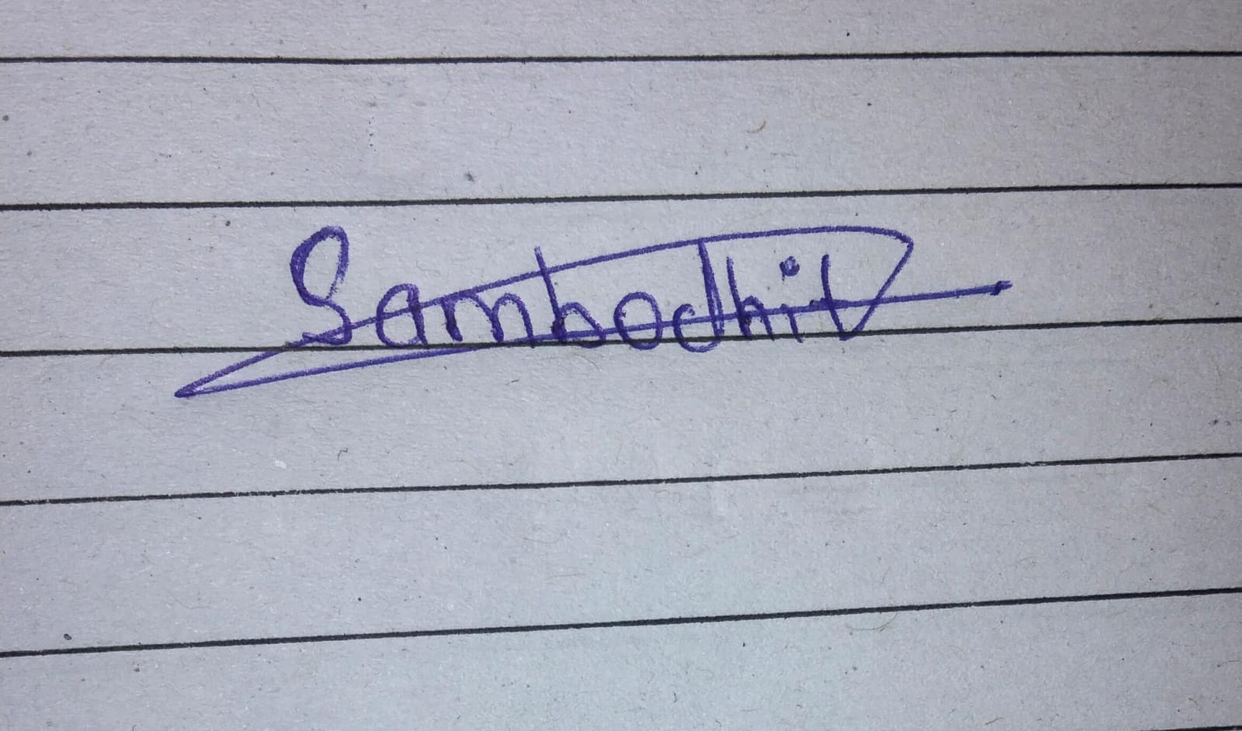

[Sambodhit Chavhan](mailto:23070511@ycce.in)  
 **Name and Signature of Student**  
 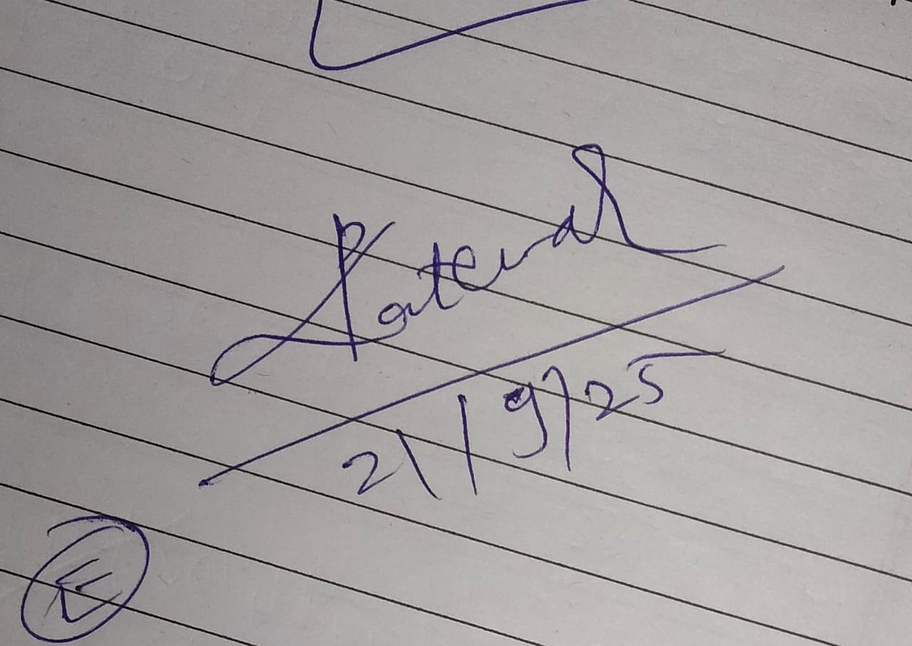

## Signature of Teacher and Date

(Signature and Date in Handwritten)

# Department of Computer Technology

### Vision of the Department

*To be a well-known centre for pursuing computer education through innovative pedagogy, value-based education and industry collaboration.*

### Mission of the Department

*To establish learning ambience for ushering in computer engineering professionals in core and multidisciplinary area by developing Problem- solving skills through emerging technologies****.***

| **Session** | **2024-25 (ODD)** | **Course Name** | **Computer vision Lab** |
| --- | --- | --- | --- |
| **Semester** | **7** | **Course Code** | **CT** |
| **Roll No** |  | **Name of Student** |  |

| Practical Number | 2 |
| --- | --- |
| Course Outcome | * By the end of this task, students will be able to: * Understand the concept of image convolution and its use in digital image processing. * Implement a low-pass filter (smoothing filter) with convolution to reduce sharp changes in intensity. * Use practical programming skills in image processing with the right libraries. * Examine the effect of smoothing on input images and compare the results before and after convolution. |
| Aim | write a program to apply convolution process on an input image for  image smoothing |
| Problem Definition | Apply the filters :  1.averaging_filter = ones(3,3) / 9; 2.gaussian_filter = fspecial(‘gussain’,[5 5], 1.5); |
| Theory  (100 words) | FILTERS USED FOR IMAGE SMOTHING  Average (or mean) and Gaussian filters are used for image  smoothing and noise reduction, but they differ in how they achieve  this.  Average filters apply a simple averaging of pixel values within a  kernel.  Gaussian filters use a weighted average where the center pixel  has the highest weight, decreasing with distance.  This leads to Gaussian filters better preserving image details like  edges and corners compared to average filters.  averaging_filter = ones(3,3) / 9;  This creates a 3x3 averaging filter. Each element in the filter is 1/9, meaning each  pixel in the 3x3 neighborhood will contribute equally to the smoothed output pixel.  gaussian_filter = fspecial(&#39;gaussian&#39;, [5 5], 1.5);  This uses the fspecial function to create a 5x5 Gaussian filter with a standard  deviation (sigma) of 1.5. Gaussian filters are commonly used for smoothing as they  provide a weighted average, giving more importance to central pixels. |
| Procedure and Execution  (100 Words) | Algorithm:  **Algorithm:**  **Start the program.**  **Read the input image from the specified file path.**  **Convert the image to grayscale to reduce computational complexity.**  **Convert the grayscale image to double precision for accurate filtering operations.**  **Define an averaging filter (3×3 matrix with equal weights, normalized by 15).**  **Apply convolution using the averaging filter with replication of border pixels.**  **Define a Gaussian filter of size 5×5 with a standard deviation of 1.9.**  **Apply convolution using the Gaussian filter with replication of border pixels.**  **Display results: original image, grayscale image, smoothed image with the averaging filter, and smoothed image with the Gaussian filter in subplots.**  **End.** |
| Code:clear all;  close all;  clc;  original_image = imread("C:\Program Files\MATLAB\R2024b\toolbox\images\imdata\tape.png");  gray_img = rgb2gray(original_image );  original_image_double = im2double(gray_img );  averaging_filter = ones(3, 3) / 15;  smoothed_avg = imfilter(original_image_double, averaging_filter, 'replicate');  gaussian_filter = fspecial('gaussian', [5 5], 1.9);  smoothed_gauss = imfilter(original_image_double, gaussian_filter, 'replicate');  figure;  subplot(1,4,1);  imshow(original_image);  title('Original Image');  subplot(1,4,2);  imshow( gray_img);  title('Gray Image');  subplot(1,4,3);  imshow(smoothed_avg);  title('Averaging Filter');  subplot(1,4,4);  imshow(smoothed_gauss);  title('Gaussian Filter'); |
| Output: |
| Output Analysis | The program successfully applied convolution to the given image using two types of smoothing filters.  The Original Image shows the raw input in color.  The Gray Image represents the intensity version of the input, which reduces processing complexity.  The Averaging Filter Output produced a blurred image. Noise is reduced, but edges and fine details also look less sharp.  The Gaussian Filter Output provided a smoother image while still keeping the main object boundaries. This makes Gaussian filtering more effective for reducing noise without losing much detail.  Overall, the results show that both filters achieve smoothing. However, the Gaussian filter offers better quality by balancing noise reduction and edge preservation. |
| Link of student Github profile where lab assignment has | https://github.com/sambodhit-chavhan/CV- |

# Department of Computer Technology

### Vision of the Department

*To be a well-known centre for pursuing computer education through innovative pedagogy, value-based education and industry collaboration.*

### Mission of the Department

*To establish learning ambience for ushering in computer engineering professionals in core and multidisciplinary area by developing Problem- solving skills through emerging technologies****.***

| been uploaded |  |
| --- | --- |
| Conclusion |  |
| Plag Report (Similarity index < 12%) |  |
| Date | 21/9/25 |